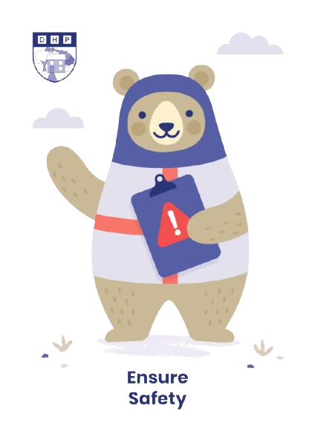

**Dene House Primary School**

Manor Way, Peterlee, Co. Durham. SR8 5RL. Tel (0191) 586 2937

Email address: [office@denehouseprimary.co.uk](mailto:office@denehouseprimary.co.uk)

Website: [www.denehouse-pri.durham.sch.uk](http://www.denehouse-pri.durham.sch.uk)

**Lockdown Policy & Procedures**

|  |  |
| --- | --- |
| Date of last review: | Sept 2024 |
| Date of next review: | Sept 2025 |
|  | |
| Lead member of staff: | Mr L Blake (Head Teacher) |
|  |  |

**Rationale**

As part of our Health and Safety policies and procedures, the school has a Lockdown Policy.

On very rare occasions, it may be necessary to seal off the school so that it cannot be entered from the outside. This will ensure that pupils, staff and visitors are safe in situations where there is a hazard in the school grounds or outside the school in the near vicinity.

A lockdown is implemented when there are serious security risks of the premises due to, for example, near-by chemical spillage, proximity of dangerous dogs, serious weather conditions or attempted access by unauthorised persons intent in causing harm/damage.

NaCTSO (National Counter Terrorism Security Office) **Guidance**

In January 2016, NaCTSO provided the following advice to leaders of schools and other Educational Establishments for Reviewing Protective Security.

**Bomb threats: Procedures for handling bomb threats**

Most bomb threats are made over the phone and the overwhelming majority are hoaxes, made with the intent of causing alarm and disruption. Any hoax is a crime and, no matter how ridiculous or unconvincing, must be reported to the police.

Be alert, but not alarmed!

On receipt of a “bomb threat” – Dial 9 for an outside line, then 999 and police will respond. You should always consider their advice before a decision is taken to close or evacuate.

**Notification of Lockdown**

Staff will be notified lock down procedures are to immediately take place via the school buzzer system – the buzzer will be sounded 3 times by HT/Office staff. If, for any reason, the buzzer system is unresponsive, office staff will inform adults by stating ‘ATTENTION LOCK DOWN.’

***NB Staff leading Forest School will need to take a walkie talkie with them and they will be alerted of Lock Down from the Office Staff.***

1. These signals will activate a process of children being ushered into the school building if on the playgrounds or Forest School as quickly as possible and the locking of the school’s offices, fob connecting doors and all outside doors where it is possible to remain safe.
2. At the given signal the children will return to their classroom and the staff will ensure the windows and doors are closed/locked and screened where possible and children are positioned away from possible sightlines from external windows/doors. Classroom lights, white boards and computer monitors to be turned off. Corridor/toilet lights to stay on
3. Fire Wardens will check toilets and communal areas.
4. Children or staff not in class for any reason will proceed to their own classroom immediately.
5. Staff and pupils at Forest School will enter school via the nearest entrance and proceed immediately to their classroom.

***Staff and pupils will remain in class until given the all clear by the HT/Office Staff. There will be no unnecessary movement around school.***

***In the event that children need to move from their classroom they will transfer to the corridor/hall as appropriate.***

1. Staff to support children in keeping calm and quiet. Teachers conduct a roll call and notify the office immediately of any pupils not accounted for. SLT will conduct a search for the missing pupil/s eg checking toilets, intervention rooms etc
2. Staff to remain in lockdown positions until informed by key staff e.g. Senior Leadership Team or School Administrator in person that there is an all clear.

**Staff Roles:**

1. Front office staff ensure that their office(s) are locked and police called if necessary.

2. Head or office staff member locks the school’s front doors and all other entrances.

3. Site Manager to head to the Main Office, after ensuring all perimeter gates are locked (if it is safe to do so).

4. Individual teachers/HLTAs/TAs lock/close classroom door(s) and windows. Nearest adult to check exit doors are shut and locked.

5. Catering Staff to lock back door to kitchen, turn off lights and move to the school hall.

***INDIVIDUAL STAFF CANNOT SIGN OUT OR LEAVE THE PREMISES DURING LOCKDOWN WITHOUT PRIOR AGREEMENT OF THE HEADTEACHER BEFORE LEAVING***

**Communication with parents**

* Parents will be notified when school has had a ‘Lock Down’ drill.
* Parents will be notified as soon as it is practical to do so via the school’s established communication network when a Lock Down has been necessary – text message/Class Dojo/telephone.
* Depending on the type and severity of the incident, parents may be asked NOT to collect their children from school as it may put them and their child at risk.
* Pupils will not be released to parents during a lock down.
* Parents will be asked not to call school as this may tie up emergency lines.
* If the end of the day is extended due to the lock down, parents will be notified and will receive information about the time and place pupils can be picked up from office staff or emergency services.
* A letter to parents will be sent home as the nearest possible day following any serious incident to inform parents of context of lockdown and to encourage parent to reinforce with their children the importance of following procedures in these very rare circumstances.

**Lockdown drills**

Lock down practices will take place a minimum of once a year to ensure everyone knows exactly what to do in such a situation. Monitoring of practices will take place and debriefed to staff so improvements can be made.

**Review**

This policy and procedures will be reviewed annually as a part of Emergency Fire and Evacuation Plan and H+S Policy.