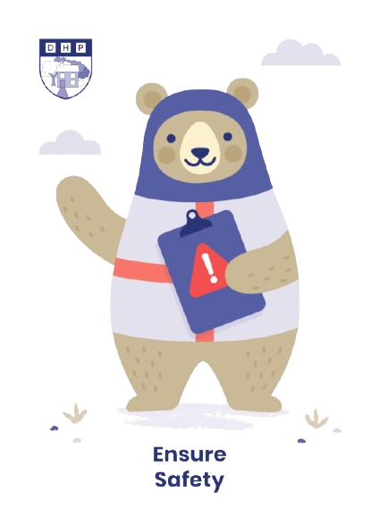

**Dene House Primary School**

Manor Way, Peterlee, Co. Durham. SR8 5RL. Tel (0191) 586 2937

Email address: [office@denehouseprimary.co.uk](mailto:office@denehouseprimary.co.uk)

Website: [www.denehouse-pri.durham.sch.uk](http://www.denehouse-pri.durham.sch.uk)

**Managing Medication Policy**

|  |  |
| --- | --- |
| Date of last review: | Sept 2024 |
| Date of next review: | Sept 2025 |
|  | |
| Lead member of staff:  Supported by | Mr L Blake (Head Teacher)  Miss Deborah Hartley |

**Dene House Primary School**



**MANAGING MEDICATION POLICY**

**Key Information:**

* Medicines should only be administered at school when it would be detrimental to a child’s health or school attendance not to do so;
* No child under 16 should be given prescription or non-prescription medicines without their **parent’s written consent**. Non-prescription medication WILL NOT be administered . (see details of procedure outlined later in policy);
* School will only accept prescribed medicines that are **in-date, labelled, provided in the original container as dispensed by a pharmacist and include instructions for administration, dosage and storage**. The exception to this is insulin which must still be in date, but will generally be available to schools inside an insulin pen or a pump, rather than in its original container.
* A child under 16 should never be given medicine containing aspirin unless prescribed by a doctor. Medication, eg for pain relief, should never be administered without first checking maximum dosages and when the previous dose was taken;
* Where clinically possible, medicines should be prescribed in dose frequencies which enable them to be taken outside school hours;

**Storing Medication:**

* All medicines must be stored safely.
* **Emergency Medication:** Medicines and devices such as asthma inhalers, blood glucose testing meters and adrenaline pens should be always readily available to children and not locked away. Inhalers will be kept in a labelled bag in each classroom and must be taken out when the class are outdoors/off site.**All children in the class must know where emergency medication is kept and all staff in school must be able to locate the medication quickly and easily.**
* **Non-emergency medication (for example prescription antibiotics) and controlled substances:** These medications must be **locked away securely in either the First Aid Cabinet or locked fridge in the First Aid room**. All first aid staff will have a key for the First Aid cabinet and the key for the fridge will be kept in the office.

**Who can give medication?**

* In all planned cases of administering medication, this will be done by a member of staff adequately trained in administering medication. In the case of administering emergency medication, for example medication for epilepsy, epi pen or inhalers, the first point of call should always be a first aider, however in an emergency, any member of staff may administer the medication, as long as they have had adequate training. All medication must be given in accordance with the prescriber’s instructions.
* All cases of medicine being administered must be recorded in school (see procedure detailed later in policy).

**School Trips:**

* A First Aider will always accompany children on school trips
* It is the responsibility of the teacher in charge to take a first aid bag with them on any school visit.
* On trips or residential visits, staff will carry any medication needed for individual children.

**Giving Medication**

* New form – see end of policy

**Procedure:**

* Medication comes to the office and is handed to either *Mrs Brammer* or *Mrs Hood.*
* Parents are handed a consent form to complete, labels are checked then the medication and consent form will be stored appropriately. *Miss Hartley, Miss Smith, Mrs Lowery, Mr Blake* or *Mrs Watson* will then be informed that there is medication to administer, what time, where it is stored and the child’s name.
* Medication is **stored securely** in either the locked storage container or first aid fridge;
* At the required time, *Miss Hartley, Miss Smithm Mrs Lowery, Mr Blake* or *Mrs Watson* will administer the medication to the child. The administering sheet will be then completed, signed and returned to the storage area with the medication;
* The next day, the process is repeated.

**Dene House Primary School**

**Record of medicine administered to an individual child**

|  |  |  |
| --- | --- | --- |
| **Name of Child:** | | **Class:** |
| **Name of Medication** | **Dose & Frequency:** | |
| **Date Received:** | **Expiry Date:** | |

|  |  |  |  |  |
| --- | --- | --- | --- | --- |
| **Date** | **Time** | **Dose** | **Sig. of member of staff** | **Comments** |
| **Mon** |  |  |  |  |
| **Tue** |  |  |  |  |
| **Wed** |  |  |  |  |
| **Thurs** |  |  |  |  |
| **Fri** |  |  |  |  |

|  |  |  |  |  |
| --- | --- | --- | --- | --- |
| **Date** | **Time** | **Dose** | **Sig. of member of staff** | **Comments** |
| **Mon** |  |  |  |  |
| **Tue** |  |  |  |  |
| **Wed** |  |  |  |  |
| **Thurs** |  |  |  |  |
| **Fri** |  |  |  |  |

|  |  |  |  |  |
| --- | --- | --- | --- | --- |
| **Date** | **Time** | **Dose** | **Sig. of member of staff** | **Comments** |
| **Mon** |  |  |  |  |
| **Tue** |  |  |  |  |
| **Wed** |  |  |  |  |
| **Thurs** |  |  |  |  |
| **Fri** |  |  |  |  |