

**Dene House Primary School**

Manor Way, Peterlee, Co. Durham. SR8 5RL. Tel (0191) 586 2937

Email address: [office@denehouseprimary.co.uk](mailto:office@denehouseprimary.co.uk)

Website: [www.denehouse-pri.durham.sch.uk](http://www.denehouse-pri.durham.sch.uk)

**Curriculum Policy**

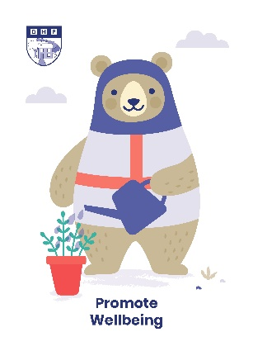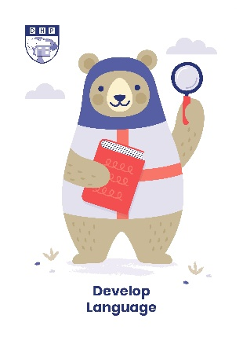

|  |  |
| --- | --- |
| Date of last review: | Sept 2024 |
| Date of next review: | Sept 2025 |
|  | |
| Lead member of staff: | Mr L Blake (Head Teacher) |
| Nominated Governor: |  |

**INTRODUCTION**

Dene House Primary School curriculum aims are informed by the School aims and objectives. The Education Reform Act 1988 and subsequent legislation places a statutory duty on the Local Authority Schools to ensure that students follow the National Curriculum. However as an Academy we are able to set and implement our own curriculum.

Dene House Primary School have taken the decision to implement the revised 2014 National Curriculum but we supplement it with additional “non-compulsory” areas of learning which enhance children’s social, moral, spiritual and cultural development.

**PUPIL ENTITLEMENT**

Dene House Primary School recognises that all pupils are entitled to a curriculum which is characterised by breadth, balance, coherence, relevance, differentiation and progression. We attach the following meanings to these terms:

**Breadth**

A broad curriculum will bring pupils into contact with the elements of learning (knowledge, concepts, skills and attitudes) and the areas of learning experience (aesthetic/creative, human and social, linguistic and literary, mathematical, moral, physical, scientific, spiritual and technological).

**Balance**

A balanced curriculum will ensure that each area of learning and experience will be given appropriate attention in relation to the others and to the curriculum as a whole.

**Coherence**

A coherent curriculum will be planned as a whole and will embrace the different areas of learning and experience, so that these do not appear as discreet and unconnected but as contributing to overall progress and achievement, for example, using a historical topic as a context to teach other subjects or using a Class novel to bring subjects together around the same theme.

**Relevance**

A relevant curriculum will link schoolwork to pupils’ own experience and make plain the application of what is learned to adult life. This means that a 'planned' curriculum will change to reflect the current needs/interests of the children being taught, for example a class may go away from their planned topics for a week to research a topical event that they are interested in.

**Differentiation**

A differentiated curriculum will satisfy the broad aims of education and be carefully matched to pupils’ developing abilities, aptitudes and individual needs.

**Basic Skills**

Through accurate differentiation and an interrelated theme and class novel based curriculum, we focus on teaching the 'basic skills' in reading, writing and maths in as many different subjects and contexts as possible.

**Teaching and Learning Approaches**

Teaching and Learning at Dene House Primary School places emphasis upon the notion that teaching and learning processes are as significant as curriculum content in determining pupil progress and achievement. To this end we seek to develop shared experience between teachers and learners. We encourage teachers to review their teaching methodology and monitor approaches through classroom observation and professional review meetings, building in CPD strategically to support teachers in developing their practice. We also recognise the importance of shared experience between learners themselves and that teachers can learn from pupils. We value non-formal learning situations as a distinctive aspect of the ethos of the school.

In this context and within the financial, physical and human resources available to the school through the delegated budget, we will endeavour to:

• promote the view that learning should be experienced as something which is enjoyable, engaging, rewarding and confidence building;

• equip pupils with the tools of learning and give a high priority to English, mathematics, speaking and listening skills, the application of Information and Communication Technology (ICT) and investigation, taught through a wide range of experiences;

• relate the content and delivery of the curriculum to the cultural, linguistic, social and religious experiences of pupils and their families so that pupils can contribute actively to their own learning;

• develop pupils’ understanding of the world in which they live through their involvement in the community and exploration of its economic, industrial, political, ecological, religious and social dimensions;

• Use out of school learning e.g. school trips, outdoor learning to enrich the curriculum and give children an opportunity to learn and apply their learning in different contexts;

• encourage pupils to be self-confident, self-disciplined, courteous, co-operative and constructively critical;

• provide opportunities for pupils to reflect systematically upon their activities and experiences;

• give pupils a sense of success through their achievements;

• regard assessment as an integral and valuable element of the learning process, in order to diagnose difficulties and chart progress;

**ASSESSMENT, PROGRESSION AND RECORDING ACHIEVEMENT**

Dene House Primary School will undertake the formal assessment of each pupil's achievement in relation to some Subjects of the National curriculum, along with the recording and publication of results in accordance with the procedures set out in statutory and other guidance. **Details of assessment can be found within our assessment policy.**

The prior attainment data of each pupil will be used to inform our expectations of the progress to be made by individuals. A mixture of process and achievement targets and formative and summative assessment methods will be employed to encourage and measure individual progress. We will follow policy and practices that are designed to ensure pupils improve and progress to realise their potential. These approaches will be characterised by coherence and quality in:

• the detailed objectives and guidance set down in schemes of work and teacher's lesson plans as they affect the learning needs of individual students to include:

* clear, shared learning objectives and success criteria

* consistent marking procedures

* a philosophy that encourages creativity and the maximisation of all opportunities

* standardised and other forms of testing;

• working with different schools and phases - particularly between our cluster of schools, local secondary schools, further education or training, higher education.

• home and school perceptions of pupil progress, including parent’s evenings, rewards and sanctions, contact with parents via letter, guidance and counselling procedures;

• a staff development programme in support of the School Improvement Plan; arrangements which encourage full, individual and corporate participation by staff in the development and review of the curriculum;

• arrangements for providing parents, prospective parents, governors, and others with information about the curriculum of the school and pupils' achievements in accordance with the national requirements.

**ENRICHMENT**

We believe that our children learn best when we make their learning fun, engaging and experiential. We enhance children’s learning experiences in a number of ways:

**Trips** – both class and whole school, chosen to enrich the children’s experience of the curriculum and bring learning to life;

**Local Area** – as well as trips further afield, the children have opportunities to explore their local area eg Castle Eden Dene, visits to the local church and surrounding village, forest school;

**Visitors** – providing children with experiences that immerse them in learning and opportunities to meet people from different walks of life who have first-hand experience in different learning contexts e.g. police, authors;

**Workshops** – an opportunity for children to engage in hands-on experiences.