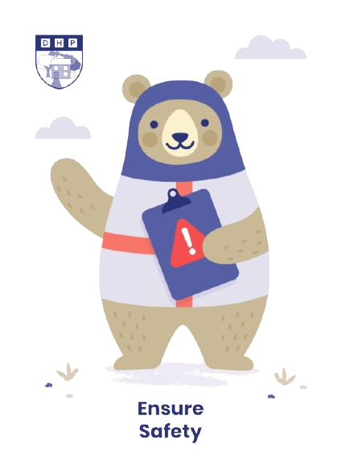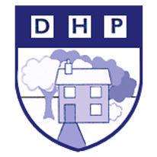

**Dene House Primary School**

Manor Way, Peterlee, Co. Durham. SR8 5RL. Tel (0191) 586 2937

Email address: [office@denehouseprimary.co.uk](mailto:office@denehouseprimary.co.uk)

Website: [www.denehouse-pri.durham.sch.uk](http://www.denehouse-pri.durham.sch.uk)

**School Uniform Policy**

|  |  |
| --- | --- |
| Date of last review: | Sept 2024 |
| Date of next review: | Sept 2025 |
|  | |

**Aim**

Uniform is compulsory at Dene House Primary School. It is our policy that all children should wear clothing that is in keeping with a purposeful learning ethos. We believe that wearing uniform encourages a sense of identification, equality, pride and a belonging to Dene House Primary School. We also believe uniform should be practical, inclusive and affordable.

**Uniform**

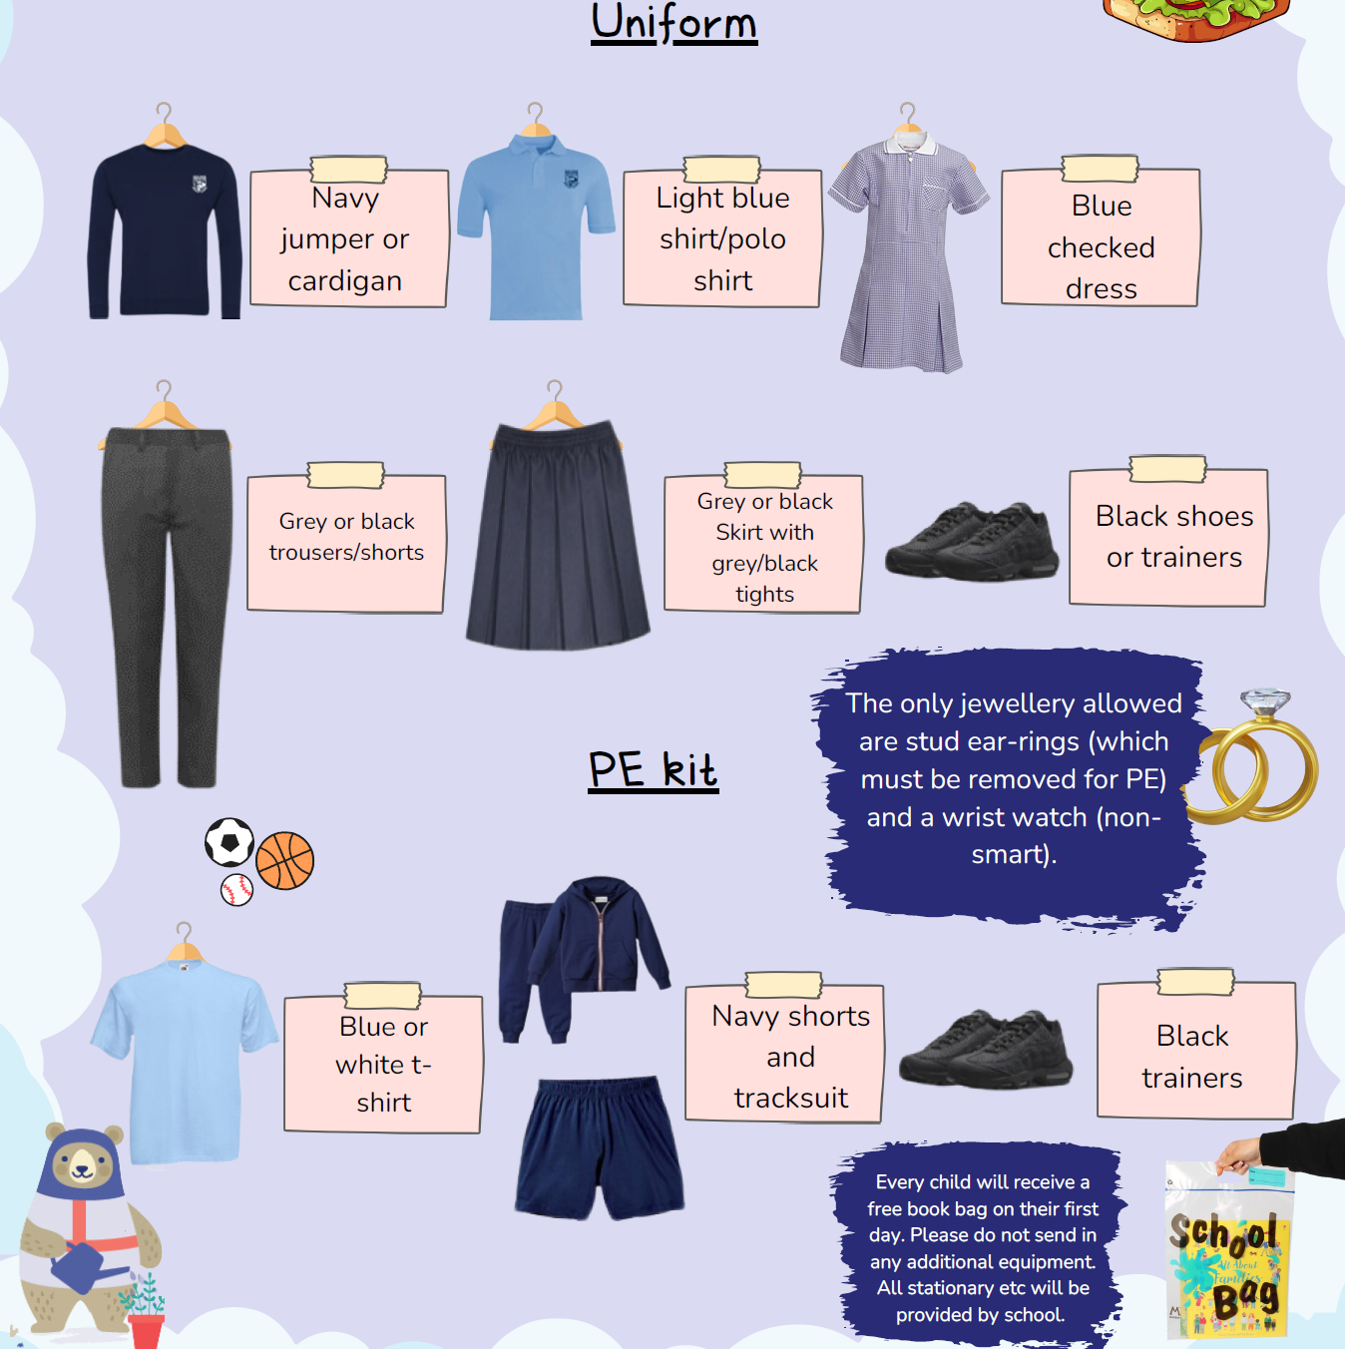

School does not stock trousers/skirts/dresses etc - these can be purchased from the usual outlets. Please ensure your child wears suitable shoes for school.

Blue sweatshirts/cardigans can be bought from any outlet.

If you would like uniform embroidered with the school badge, this can be ordered from the School Outfit online: <https://theschooloutfit.co.uk/collections/dene-house-primary-school>

Make-up and nail varnish is discouraged.