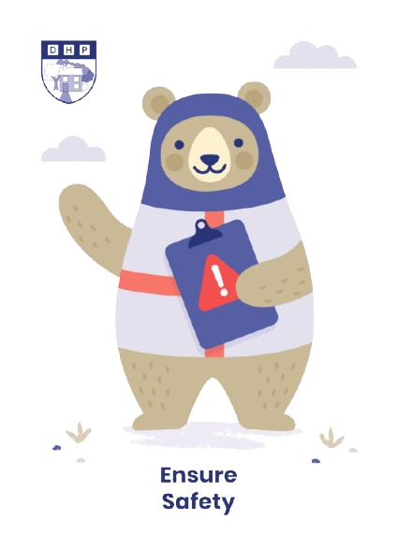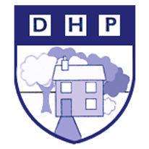

**Dene House Primary School**

Manor Way, Peterlee, Co. Durham. SR8 5RL. Tel (0191) 586 2937

Email address: [office@denehouseprimary.co.uk](mailto:office@denehouseprimary.co.uk)

Website: [www.denehouse-pri.durham.sch.uk](http://www.denehouse-pri.durham.sch.uk)

**Nut Free School Policy**

|  |  |
| --- | --- |
| Date of last review: | Sept 2024 |
| Date of next review: | Sept 2025 |
|  | |
| Lead member of staff: | Mr L Blake (Head Teacher) |

At Dene House Primary School, we are committed to providing a safe and inclusive environment for all students, including those with nut allergies. Nut allergies can be life-threatening, and it is essential that we take proactive measures to reduce the risk of exposure to nuts within our school premises. This nut-free policy outlines the guidelines and procedures to be followed by students, staff, and visitors to ensure the safety of all individuals with nut allergies.

**Policy Statement**

**Prohibition of Nuts**: Nuts, nut products, and any food items containing nuts are strictly prohibited on school grounds, including classrooms, canteens, and common areas.

**Nut-Free Environment:** Dene House Primary is designated as a nut-free environment to minimise the risk of accidental exposure to allergens for students with nut allergies.

**Responsibilities:**

Students, where appropriate, are expected to refrain from bringing nuts or nut-containing products to school. They should also be vigilant in checking food labels and notifying school staff if they suspect any food item may contain nuts.

All staff members are responsible for enforcing the nut-free policy and monitoring compliance among students. Staff should also be trained in recognizing signs of an allergic reaction and administering emergency medication if necessary.

Parents are encouraged to support the nut-free policy by providing nut-free lunches and snacks for their children. They should also inform the school of any nut allergies their child may have and provide necessary medical information.

**Allergy Action Plan:**

- Students with nut allergies must have an allergy action plan on file at the school, outlining emergency procedures to be followed in case of an allergic reaction.

- Parents/guardians of students with nut allergies are required to provide the school with emergency contact information and prescribed medication, such as epinephrine auto-injectors.

**Communication:**

- The school will communicate the nut-free policy to all students, staff, and parents at the beginning of each academic year.

- Any changes or updates to the policy will be communicated promptly to ensure awareness and compliance.

**Enforcement and Compliance:**

Violation of the nut-free policy may result in disciplinary action in accordance with the school's code of conduct. We rely on the cooperation and support of the entire school community to ensure the effectiveness of this policy in creating a safe environment for all students.

**Review and Revision:**

This nut-free policy will be reviewed annually to assess its effectiveness and make any necessary revisions to improve the safety of students with nut allergies.

By adhering to this nut-free policy, we demonstrate our commitment to the well-being and safety of all students at Dene House Primary School. Thank you for your cooperation in creating a nut-free environment for our school community.