Dene House Primary School
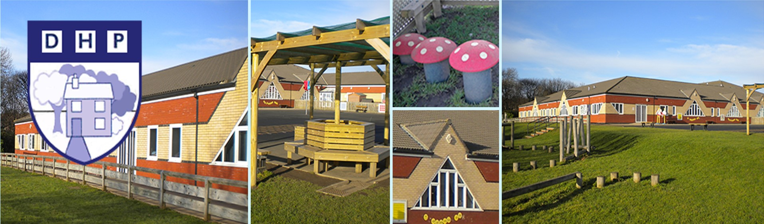

FIRE EMERGENCY PLAN
SMP/FEP/001 Version 1

2024/25

Introduction

All DCC premises should have a written plan of how they intend to deal with a fire situation. The purpose of the emergency plan is to ensure that all people within the premises know what to do in the event of a fire and that the building can be safely evacuated.

This emergency plan for Dene House Primary School
has been developed in conjunction with the premises fire risk assessment and has been made available to all employees, and the employees of other organisations that share the premises.

The emergency plan includes the following:

Section
1. | Fire safety roles and responsibilities | 3
2. | Evacuation procedure in detail | 4
3. | Assembly points | 7
4. | Calling the emergency services | 7
5. | People needing assistance with evacuating the premises | 7
6. | Fire marshals | 7
7. | Arrangements for fighting a fire | 8
8. | Other specific duties that need to be completed (and the person responsible) | 8
9. | Plans to deal with people when they have evacuated the building | 8
10. | Useful contacts | 9

Appendices
Appendix 1 - Identification of key escape routes | 10
Appendix 2 - Plans of Assembly points | 13
Appendix 3 – Fire Marshals | 14
Appendix 4 – Fire Marshal search areas. | 15
1. FIRE SAFETY ROLES AND RESPONSIBILITIES.

The Following have responsibilities for fire safety at Dene House Primary School

Head Teacher and Business Development Manager
– will ensure there is a Fire Safety Risk assessment and that preventive and protective measures are in place.

Site Manager – will during the course of his duties ensure that fire safety measures are in place.

Teachers – will take charge of pupils to ensure their class evacuates the building in an emergency.
- will actively ensure that the means of escape in their classroom/the school is never obstructed or blocked.

All other staff – will cooperate in the emergency procedures in event of a fire.

Employees
Employees will be provided with clear and relevant information on the risks to them identified by the fire risk assessment, about the measures to be taken to prevent fires, and how these measures will protect them if a fire breaks out.

The school will consult employees (or their elected representatives) about nominating people to carry out particular roles in connection with fire safety and about proposals for improving the fire precautions.

Employment of children
Before the employment of a child the Young Employee risk assessment, as detailed in the School Health & Safety Policy and Procedures Manual, will include the risk from fire and the measures taken to control the risk.

Non-Employees
The school will inform non-employees, such as students and temporary or contract workers, of the relevant risks to them, and provide them with information about the fire safety procedures for the premises. The information will include any part they will be expected to play in the evacuation of pupils from the premises.

Non-employees will always sign either the visitor’s book or make an entry in the e-sign in system. These will be checked in the event of a fire to ensure all visitors have been evacuated safely.

Shared Premises
In premises that are shared with another organisations the school will co-operate and co-ordinate with other responsible persons to inform them of any significant risks, and how the school will seek to reduce/control those risks which might affect the safety of their employees.

Other organisations using the premises will be issued with a copy of the schools emergency procedures and will be expected to cooperate with the preventative measures put in place by the school.
- EVACUATION PROCEDURE IN DETAIL.

DETAILS OF THE SCHOOLS EMERGENCY PLAN

How people will be warned if there is a fire?

The Fire Alarm will sound as a continuous ring bell throughout the school.

What staff should do if they discover a fire?

- Staff should break the nearest break glass point on their way out of the building and report the location of the fire to the Headteacher, Business Development Manager or Site Manager (if on site).

AND

- Staff should not attempt to tackle a fire unless it is safe to do so, and that they are confident they have received sufficient instruction to use firefighting equipment safely.

- Staff should evacuate the building by the nearest available fire exit.

- Staff should not stop to collect personal belongings on their way out.

- Under no circumstances should anyone attempt to re-enter the building until told to do so by the Premises Manager/Headteacher.

What pupils or visitors should do if they discover a fire?

- Pupils should inform the nearest adult of the location of the fire and leave the building by the nearest exit.

- Visitors should exit the building by the nearest exit and activate the ‘break glass’ point as they leave the premises. They should inform a member of staff of the location of the fire and pass on any information that they might have that could be of assistance to the emergency services.

How the evacuation of the premises should be carried out?

- All occupiers of the premises should exit by the nearest available fire exit.

- Staff responsible for pupils should ensure that all pupils in the class have left the room before exiting themselves.
(i.e. the last person out of an area should be an adult.)

- Staff should close the door behind them on leaving the room.

- Staff and pupils should move quickly and quietly but do not run.

- Teachers will take the Fire Register from the classroom with them and the School Secretary will take the visitor register to the assembly points.

- All pupils, staff and visitors will go immediately to the assembly points. If the emergency evacuation occurs at the end of the school day or lunchtime, people will still report to the assembly points.

Procedure for checking the premises have been evacuated

- Roll calls will be made by class teachers against the register.

- Visitors and contractors will be checked against the ‘visitor signing-in book or electronic records’.

Where people should assemble after leaving the premises?

- Assembly Point- All pupils and adults should assemble on the playground, at the furthest point away from the school, in class order. Support staff should assemble with their morning class.

Identification of key escape routes & how they are accessed to escape to a place of safety

All EYFS, KS1 & 2 classes have assigned fire exit doors to the external assembly areas.
- EYFS exit onto the KS1 Playground.
- KS1 exit onto the KS1 Playground.
- KS2 exit onto the KS2 Playground.

- Kitchen Staff – will leave by the kitchen exit and assemble on the yard beside the Office Manager.

- Reception/Admin staff will leave by their allocated Key Stage exit. Headteacher and Admin staff to take mobile phones/walkie talkies with them.

Procedure for calling emergency services

On hearing the alarm, the building will be evacuated as described above. At the same time the designated person (Head Teacher/ Deputy Head / Business Manager/Site Manager) will read the fire alarm panel to identify the location of the fire.

The following procedure should be followed WHEN SAFE TO DO SO. If in any doubt get out of the building and ring the Fire Service on 999
Identify on panel where activation is located.

Search and investigate.

ONLY WHEN SAFE TO DO SO.

Is there evidence of a genuine fire?
Flames, smoke, heat unusual noise

YES – satisfied there is a genuine fire or unsure.

Leave the premises and ring 999 immediately.
No – you do not believe there a genuine fire.

1. Reset alarm at fire alarm panel.

2. If resets and stays normal – inform others to reoccupy the building. Do not call fire service.

3. If alarm reactivates (sounds again) –and you believe that the activation is a system fault, contact the property help desk. If you suspect the activation to be fire related leave the building immediately and ring 999.

5. PEOPLE NEEDING ASSISTANCE WITH EVACUATING THE PREMISES

Durham County Council operates a Personal Emergency Evacuation Plan (PEEP) Policy. Any person that needs assistance evacuating a premise should have a PEEP completed. The PEEP will give details of exactly how the evacuation will take place for that individual and the details of any persons assigned to assist.

Copies of the PEEPs documentation can be found on the H&S pages of the DCC intranet.

Y4 SW
Y5 RW
Y6 BB
Y3 MH
Y5 LL
Gareth Haywood - LTS

6. FIRE MARSHALS

People detailed in Appendix 3 have received training to be fire Marshals for the premises.

Each Fire Marshal has been given a designated area to cover; these areas are indicated on the plans attached to this document at Appendix 4.

7. ARRANGEMENTS FOR FIGHTING A FIRE.

Staff should not attempt to fight a fire unless they have been given specific training to do so and are confident they can do so without putting themselves at risk.

Fire fighting equipment is provided on the premises in various locations. Fire Marshals trained in the use of this equipment should familiarise themselves with these locations. However, they should only use this equipment if they are confident to do so without putting themselves at risk.

8. OTHER SPECIFIC DUTIES THAT NEED TO BE COMPLETED (AND THE PERSON RESPONSIBLE).

- Isolating Gas / Electricity Supplies (At the request of the Fire Service).

- Informing of Asbestos containing materials. The Senior Manager / Fire Co-ordinator

9. PLANS TO DEAL WITH PEOPLE WHEN THEY HAVE EVACUATED THE BUILDING.

In the event of a prolonged incident staff will be sent home or to work from other locations depending of service requirements.

Individual Organisations should have their own Business Continuity plans in place and make arrangements to relocate staff in the event of the building receiving significant damage.

10. USEFUL CONTACTS.

Durham and Darlington Fire & Rescue Service – 0345 3058383 or email ServiceHQ@ddfire.gov.uk

Property Help Desk –03000 267890 or email propertyhelpdesk@durham.gov.uk

Facilities Management – FacilitiesManagement@durham.gov.uk

DCC Health & Safety Team– 03000 263430 or email HSTeam@durham.gov.uk

(Fire marshal/fire extinguisher training is available from the H & S fire advisors)

Appendix 1 - Identification of Key Escape Routes.

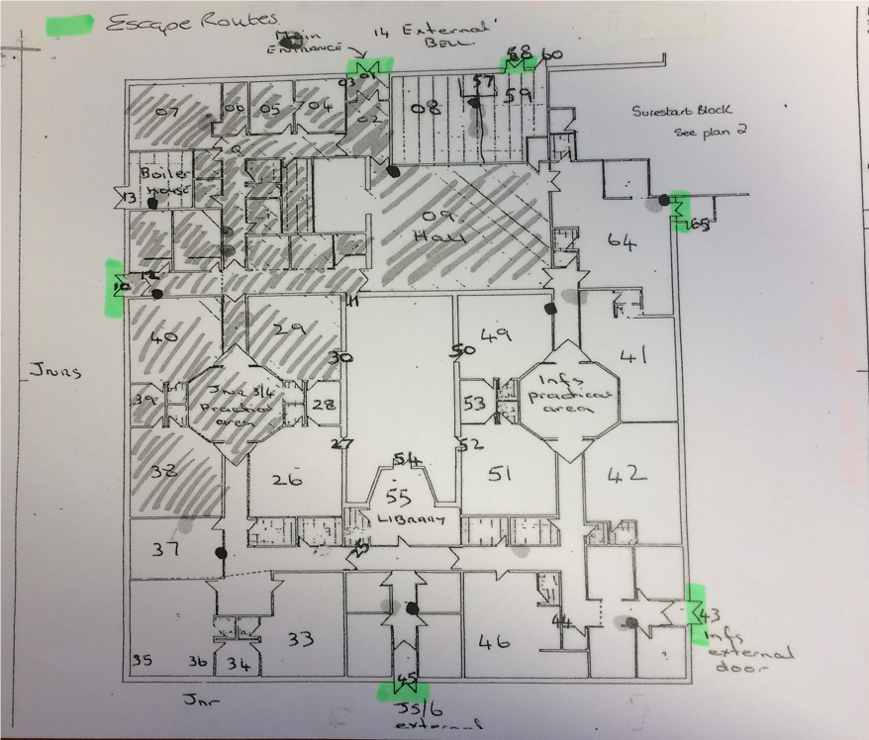

Appendix 2 – Plans of Assembly Points.

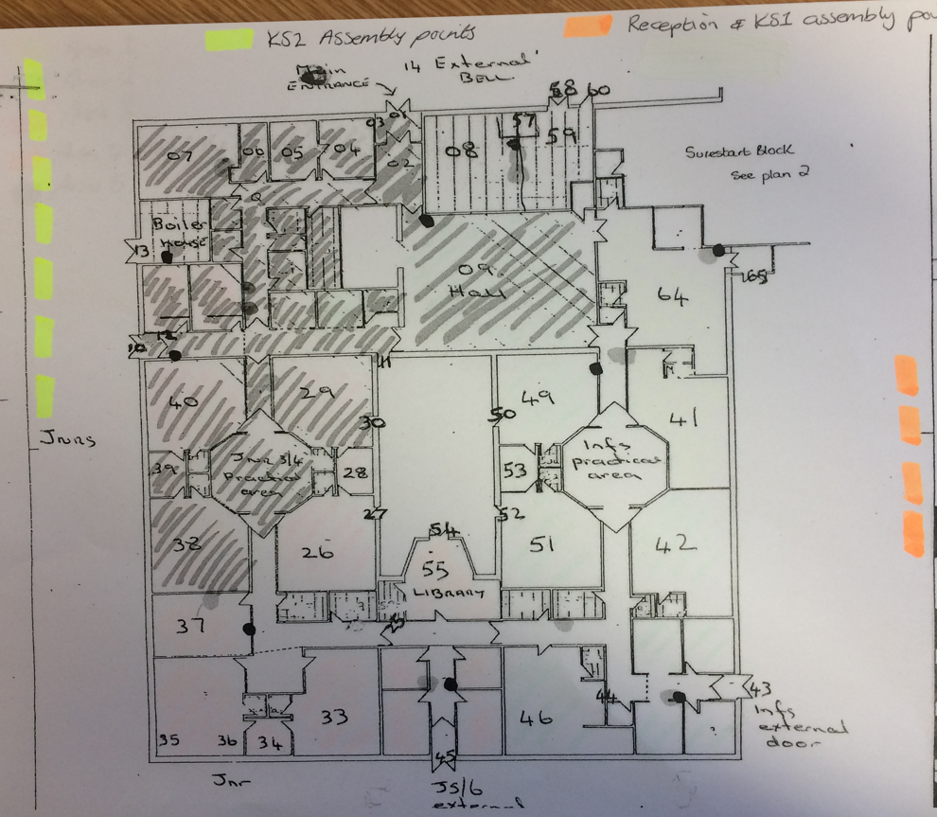
Appendix 3 & 4 – Fire Marshals.

Ground Floor.
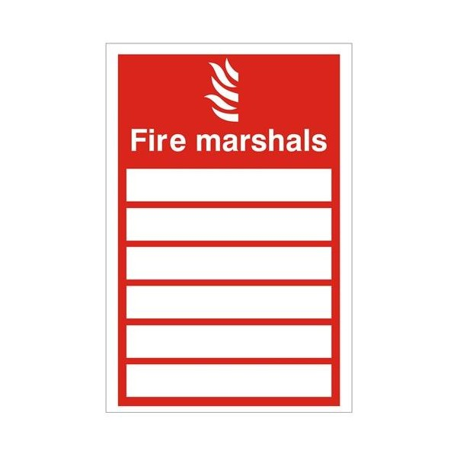

Area 1: Chloe Ferguson/Laura Lowery
Area 2 Dionne Ward/Lindsey Watson
Area 3 Stephanie Stewart/ Poppy Smith
Area 4 Sarah Cook/Susan Willis
Area 5 Valerie Hood/Lee Blake

Appendix 4 – Search Areas.

